**Woven steel and distressed denim feature in Design Museum’s landmark sari exhibition unveiled today**

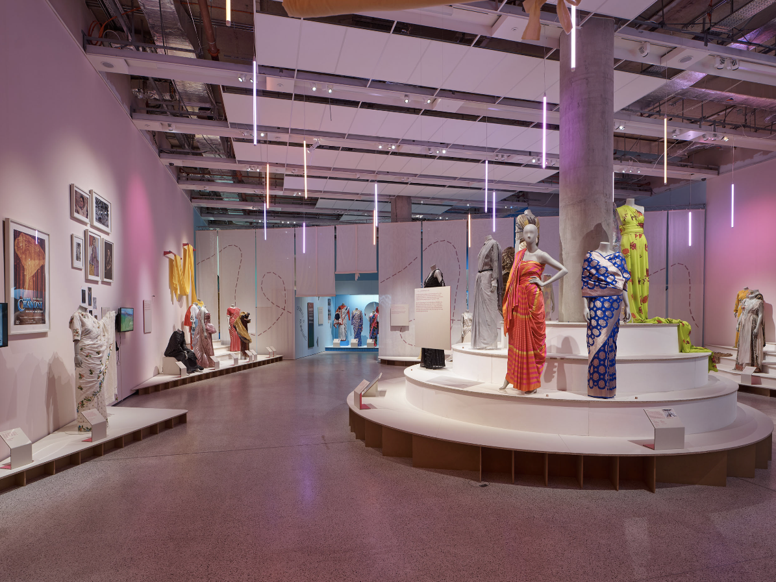© Andy Stagg for the Design Museum

***The Offbeat Sari***

19 May – 17 September 2023

the Design Museum

[**PRESS IMAGES**](https://www.dropbox.com/sh/yi2jo332at2qho5/AAAChneg6oEGXZfMd5GHAVzja?dl=0)

* **The Design Museum today unveils the first large-scale exhibition in the UK to examine the contemporary Indian sari**
* **It brings together around 60 examples of trailblazing saris, nearly all on loan from designers and studios across India**
* **Highlights include the first sari ever worn to the Met Gala, displayed in Britain for the first time — shown alongside saris made of woven steel and distressed denim**
* **It presents the sari as a site for design innovation and an expression of identity and resistance today**

The Design Museum today unveils a major exhibition examining one of the world’s most recognisable items of clothing.

The sari – which has enduring appeal and is ubiquitous across India and South Asia today – has experienced a radical 21st century overhaul. It is “experiencing what is conceivably its most rapid reinvention in its 5,000-year history.*”*

The Design Museum explores this reinvention in its summer exhibition, shedding a rare spotlight on contemporary Indian fashion for UK audiences. Today’s unveiling of the exhibition reveals a show that includes saris made of woven steel, distressed denim and the very first sari worn to the famed Met Gala, which is being shown in Britain for the first time.

*The Offbeat Sari* is the first large-scale exhibition in the UK to focus on the contemporary sari in India. It is curated by the Design Museum’s Head of Curatorial Priya Khanchandani. The show brings together around 60 examples of trailblazing saris made over the past decade, nearly all of which are on loan from designers and studios across India and have never been seen in Britain before. Through the textures, weaves, colours and drapes of these beautiful textiles, visitors will experience a unique snapshot of the fashion revolution the sari is experiencing right now.

Conventionally a single piece of unstitched fabric, the sari is inherently fluid. Adapted in drape and form over millennia, it reflects identity, social class, taste and function across time and geography, and remains an enduring part of life in India today. Yet in recent decades, for many, the sari has been considered traditional, or uncomfortable as a form of everyday clothing, especially by young people.

But now the sari has been reenergised. *The Offbeat Sari* exhibitionshows how designers, wearers and craftspeople are reshaping the ways in which the sari is understood, designed, made and worn in contemporary urban India. It presents the sari as a site for design innovation, an expression of identity and resistance, and a crafted object carrying layers of new materialities.

The sari has today been elevated as a fashion item and has emerged as a canvas for contemporary trends and attitudes. Designers in India are experimenting with hybrid forms such as sari gowns, pre-draped saris, and innovative materials such as steel. Wearers are embodying the sari as a vessel for dynamism rather than pageantry. Individuals are wearing the sari as an expression of resistance to social norms, and activists are embodying it as an object of protest. Young people in cities – who previously associated the sari with dressing up – can now be found wearing saris and sneakers on their commutes to work.

On display are a carefully chosen selection of around 60 saris by exciting designers of varied scale, from growing global brands to emerging studios. These include delicate work of designers such as Abraham & Thakore, Raw Mango, Akaaro and NorBlackNorWhite, who have been at the cutting-edge of the sari’s dynamic shift and renewed relevance. Visitors will also see saris that experiment with materials and form by designers like Amit Aggarwal, HUEMN, Diksha Khanna and Bodice. Examples of couture saris such as a copy of Tarun Tahiliani’s foil jersey sari for Lady Gaga (2010) and Abu Jani Sandeep Khosla’s ruffled sari worn by Bollywood star Deepika Padukone at Cannes Film Festival in 2022, in addition to work by Sabyasachi and Anamika Khanna, exemplify the sari’s full potential for extravagance. Alongside these are a range of styles seen on the streets of Mumbai, Delhi, Bangalore and beyond, showing how young women in cities are embracing the sari anew.

A significant highlight is the first ever sari worn at the famed Met Gala at the Metropolitan Museum of Art in New York. Designed by Sabyasachi, and styled with a gold Schiaparelli bodice, the stunning ensemble was worn by Indian businesswoman and socialite Natasha Poornawalla, and made headlines around the world in May 2022 for its dramatic mix of Indian and Western couture. At the time, designer Sabyasachi Mukherjee said “I interpreted the dress code, Gilded Glamour, with an Indian gaze that revels in our multiculturalism and the authenticity of our design, aesthetic and craft legacies.” This is the first time it has been seen in Britain, and only the second time the ensemble will have been displayed in a museum exhibition, after being shown in Monaco last summer.

The exhibition unfolds in three main sections:

**Transformations** highlights the work of the designers in India who have fuelled the experimentation of recent years, by pushing the boundaries of the sari through the creation of new genres and embracing it as an object of playful expression. Highlights include a sari adorned with sequins cut from disused X-ray images obtained from hospital waste and by Abraham & Thakore, a distressed denim sari by Diksha Khanna, and a lacquered sari drape wrapped around a plinth in a form of conceptual play on the sari by contemporary artist Bharti Kher. It also explores the work of conceptual designers who have used the sari as their canvas and created innovative forms such as the stitched sari dress and includes a series of films showcasing the varied sari drapes of India by Border&Fall.

**Identity and Resistance** will examine the role of the wearer in reforming the sari today and will exhibit how the sari can become a vessel for conveying individual identities, with a focus on India within the broader context of South Asia and as among the diaspora. Visitors will see the immense capacity of the sari to reflect a diverse range of voices and personas, how it can empower the female body, and a how it enables individual identities to flourish. This is shown through examples such as the red silk sari worn by Tamil-Swiss singer-songwriter Priya Ragu, a block-print sari worn by self-proclaimed ‘Saree Man’ Himanshu Verma and the ‘Arch’ sari by Adavid styled with a shirt by Bangladeshi architect and advocate for body positivity Sobia Ameen. There are also saris worn as a tool for protest, with examples of those worn by female demonstrators in rural India such as The Gulabi Gang and The Hargila Army.

**New Materialities** looks closely at the at the sari as a textile. It shows how the sari’s weave, texture, colour and surface form a rich canvas for the incredible creativity of craftspeople. It shows how makers and designers work symbiotically across a range of techniques, materials and stimuli to transform ways of making in the 21st century. This section draws upon India’s profound textile histories and its futures, spotlighting the intricacy of sari textiles, from weaves, patterns and colours to surface embellishment. An important example on show is a sari by Rimzim Dadu employing hair-thin stainless steel wires to create a gold sculpted wave.

**Priya Khanchandani, Head of Curatorial at the Design Museum and curator of *The Offbeat Sari*, said:** *“*The sari is experiencing what is conceivably its most rapid reinvention in its 5,000 year history. It makes the sari movement one of today’s most important global fashion stories, yet little is known of its true nature beyond South Asia. Women in cities who previously associated the sari with dressing up are transforming it into fresh, radical, everyday clothing that empowers them to express who they are, while designers are experimenting with its materiality by drawing on unbounded creativity. For me and for so many others, the sari is of personal and cultural significance, but it is also a rich, dynamic canvas for innovation, encapsulating the vitality and eclecticism of Indian culture. With last month’s news that it has become the world’s most populated country, India’s significance within contemporary culture is vast, and the sari foregrounds the country’s undeniable imagination and verve, while asserting the relevance of Indian design on a global stage.”

**Tim Marlow, the Design Museum’s CEO and Director**, said *“*It’s in the Design Museum’s mission to examine the world as it is today across geographies. *The Offbeat Sari* highlights design’s role in a huge fashion story that’s little-known outside India, providing a site for us to reflect, with our partners and lenders in India, and the South Asian diaspora here, on the impact of India's fashion creativity. Indian textiles have long been explored ethnographically in international museums and we are excited to be presenting cutting-edge Indian fashion to UK audiences in London this summer.”

**The Offbeat Sari *opens at the Design Museum on Friday 19 May and runs until 17 September 2023***. Tickets on sale now. <https://designmuseum.org/exhibitions/the-offbeat-sari>

**-Ends-**

**Notes to Editor**

**PRESS ENQUIRIES:**

Maxwell Blowfield, Senior Media and PR Manager

E: [maxwell.blowfield@designmuseum.org](mailto:maxwell.blowfield@designmuseum.org)

Press Office

E: [pr@designmuseum.org](mailto:pr@designmuseum.org?subject=RE:%20Surrealism%20and%20Design)

**Curated by**

Priya Khanchandani, Head of Curatorial at the Design Museum

**Exhibition Team**   
Rashmi Varma, associate curator

Tiya Dahyabhai, assistant curator

Studio Mutt, 3D design

Stuthi Ramesh, 2D design

**About the Design Museum:**

The Design Museum is the world’s leading museum devoted to contemporary architecture and design. Its work encompasses all elements of design, including fashion, product and graphic design. Since it opened its doors in 1989 the museum has displayed everything from an AK-47 to high heels designed by Christian Louboutin. It has staged over 100 exhibitions, welcomed over seven million visitors and showcased the work of some of the world’s most celebrated designers and architects including Paul Smith, Zaha Hadid, Jonathan Ive, Frank Gehry, Eileen Gray and Dieter Rams.

On 24 November 2016, The Design Museum relocated to Kensington, west London. John Pawson has converted the interior of a 1960s modernist building to create a new home for the Design Museum giving it three times more space in which to show a wider range of exhibitions and significantly extend its learning programme. In 2020, the Design Museum was awarded £2,968,634 by Arts Council England from the Culture Recovery Fund announced by the Department for Digital, Culture, Media and Sport, and nearly £1 million National Lottery funding through the Arts Council’s Emergency Response Fund. Since opening in Kensington in 2016, the Design Museum has hosted major exhibitions including *Stanley Kubrick: The Exhibition*, *Moving to Mars*, *Amy: Beyond the Stage*, *Sneakers Unboxed: Studio to Street*, *Electronic: From Kraftwerk to The Chemical Brothers*, *Charlotte Perriand: The Modern Life* and *California: Designing Freedom*.

[designmuseum.org](https://designmuseum.org/)

@designmuseum

