**Design Museum unveils**

**Ai Weiwei’s largest-ever Lego artwork**

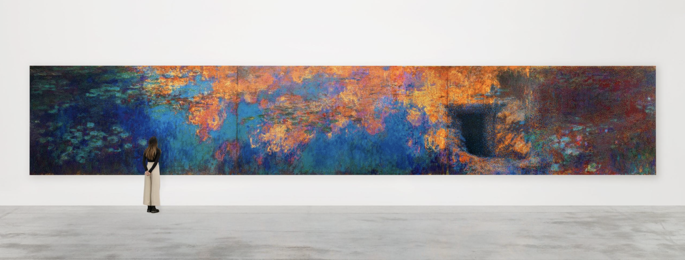

*Photo © Ela Bialkowska/OKNO studio. © Image courtesy of the artist and Galleria Continua*

***Ai Weiwei: Making Sense***

07 April – 30 July 2023

the Design Museum

[**PRESS IMAGES**](https://www.dropbox.com/sh/bfds9jp7b7h0uzt/AADzeL_Vn9DGF_0pd5P0gBC_a?dl=0)

In advance of his first design-focused exhibition — opening next month — the Design Museum today unveils a major new work by celebrated global artist Ai Weiwei.

Constructed entirely of Lego, the work is a recreation of one the most famous paintings by French Impressionist Claude Monet. It is the largest Lego artwork Ai Weiwei has ever made.

Titled *Water Lilies #1,* the work is over 15m in length and will span the entire length of one of the walls in the Design Museum gallery.

It is made from nearly 650,000 studs of Lego bricks, in 22 colours.

This vast new work will be seen in public for the very first time when the exhibition *Ai Weiwei: Making Sense* opens on Friday 7 April. It is his biggest UK show in eight years.

*Water Lilies #1* recreates Monet’s famous painting, *Water Lilies* (1914 — 26), a monumental triptych which is currently in the [collection of the Museum of Modern Art in New York](https://www.moma.org/collection/works/80220).

In the original painting, Monet depicts one of the lily ponds in the gardens of his home in Giverny near Paris. It is an image that has become world-famous for its depiction of nature’s tranquil beauty. However, the pond and gardens were a man-made construct, designed and created by Monet himself at the turn of the 20th century. He had the nearby river Epte partially diverted in order to create this idealised landscape.

By recreating this famous scene, Ai Weiwei challenges our ideas of reality and beauty. The new image has been constructed out of Lego bricks to strip away Monet’s brushstrokes in favour of a depersonalised language of industrial parts and colours. These pixel-like blocks suggest contemporary digital technologies which are central to modern life, and in reference to how art is often disseminated in the contemporary world. Challenging viewers further, included on the right-hand side of Ai’s version is a dark portal, which is the door to the underground dugout in Xinjiang province where Ai and his father, Ai Qing, lived in forced exile in the 1960s. Their hellish desert home punctures the watery paradise.

Ai Weiwei has been using Lego bricks in his work since 2014, when he used them to produce portraits of political prisoners. But *Water Lilies #1* is his largest ever creation in this medium.

*Water Lilies #1* will be seen alongside another major new Lego artwork by Ai Weiwei, which is also making its international debut at the Design Museum. First announced in January, *Untitled (Lego Incident)* is part of a series of five expansive ‘fields’ where hundreds of thousands of objects will be laid out on the gallery floor. In this field, visitors will see thousands of Lego blocks which were all donated to the artist by members of public from around the world, in response to Lego briefly refusing to sell their products to him in 2014. These donated bricks are presented at the Design Museum for the first time as a fully-formed artwork.

*Ai Weiwei: Making Sense* will be the artist’s very first exhibition to focus on design and architecture. It sees Ai using design and the history of making as a lens through which to consider what we value.

Other highlights of the exhibition include dozens of objects and artworks from throughout Ai Weiwei’s career that explore the tensions between past and present, hand and machine, precious and worthless, construction and destruction, such as his Han dynasty urn emblazoned with a Coca-Cola logo, which epitomises these clashes.

A number of examples of Ai’s ‘ordinary’ objects, where he has transformed something useful into something useless but valuable will also be shown. These include a worker’s hard hat cast in glass which becomes at once strong and fragile, and a sculpture of an iPhone that has been cut out of a jade axe-head.

Large-scale Ai Weiwei works will also be installed outside of the exhibition gallery, in the museum’s free-to-enter spaces as well as outside the building.

**Justin McGuirk, Chief Curator at the Design Museum and curator of *Ai Weiwei: Making Sense*** said: “Several of the works in this exhibition capture the destruction of urban development in China over the last two decades. With Water Lilies #1 Ai Weiwei presents us with an alternate vision – a garden paradise. On the one hand he has personalised it by inserting the door of his desert childhood home, and on the other he has depersonalised it by using an industrial language of modular Lego blocks. This is a monumental, complex and powerful work and we are proud to be the first museum to show it.”

**Ai Weiwei** said "Our world is complex and collapsing towards an unpredictable future. It's crucial for individuals to find a personalized language to express their experience of these challenging conditions. Personalized expression arises from identifying with history and memories while creating a new language and narrative. Without a personal narrative, artistic narration loses its quality. In Water Lilies #1 I integrate Monet's Impressionist painting, reminiscent of Zenism in the East, and concrete experiences of my father and me into a digitized and pixelated language. Toy bricks as the material, with their qualities of solidity and potential for deconstruction, reflect the attributes of language in our rapidly developing era where human consciousness is constantly dividing."

***Ai Weiwei: Making Sense***runs at the Design Museum from 07 April to 30 July 2023. [Tickets are available to pre-book now](https://designmuseum.org/exhibitions/ai-weiwei-making-sense).

**-Ends-**

**Notes to Editor**

**PRESS ENQUIRIES:**

Maxwell Blowfield, Senior Media and PR Manager

E: [maxwell.blowfield@designmuseum.org](mailto:maxwell.blowfield@designmuseum.org)

Press Office

E: [pr@designmuseum.org](mailto:pr@designmuseum.org?subject=RE:%20Surrealism%20and%20Design)

**Exhibition curated by**

Justin McGuirk, Chief Curator at the Design Museum

Rachel Hajek, Assistant Curator at the Design Museum

**Principal Funder**



**Exhibition Sponsor**



**With additional support from**

The Ai Weiwei Supporters Circle

**About the Design Museum:**

The Design Museum is the world’s leading museum devoted to contemporary architecture and design. Its work encompasses all elements of design, including fashion, product and graphic design. Since it opened its doors in 1989 the museum has displayed everything from an AK-47 to high heels designed by Christian Louboutin. It has staged over 100 exhibitions, welcomed over seven million visitors and showcased the work of some of the world’s most celebrated designers and architects including Paul Smith, Zaha Hadid, Jonathan Ive, Frank Gehry, Eileen Gray and Dieter Rams.

On 24 November 2016, The Design Museum relocated to Kensington, west London. John Pawson has converted the interior of a 1960s modernist building to create a new home for the Design Museum giving it three times more space in which to show a wider range of exhibitions and significantly extend its learning programme. In 2020, the Design Museum was awarded £2,968,634 by Arts Council England from the Culture Recovery Fund announced by the Department for Digital, Culture, Media and Sport, and nearly £1 million National Lottery funding through the Arts Council’s Emergency Response Fund. Since opening in Kensington in 2016, the Design Museum has hosted major exhibitions including *Stanley Kubrick: The Exhibition*, *Moving to Mars*, *Amy: Beyond the Stage*, *Sneakers Unboxed: Studio to Street*, *Electronic: From Kraftwerk to The Chemical Brothers*, *Charlotte Perriand: The Modern Life* and *California: Designing Freedom*.

[designmuseum.org](https://designmuseum.org/)

@designmuseum

